**DSA060 – DATA HANDLING AND DATA VISUALISATION FOR CLUSTERING ALGORITHMS**

**Harika A S (192224144)**

**Case Study** 1: Consider that you are with the following data table and its associated graph: Stacked Bar Chart, Line Plot, Scatter Plot and Mosaic Plot, Histogram.

**Histogram**

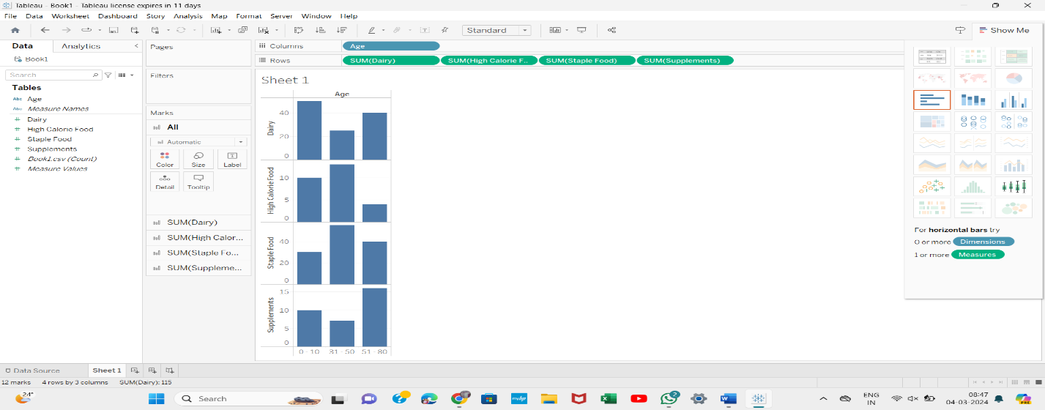

**Stacked Bar**

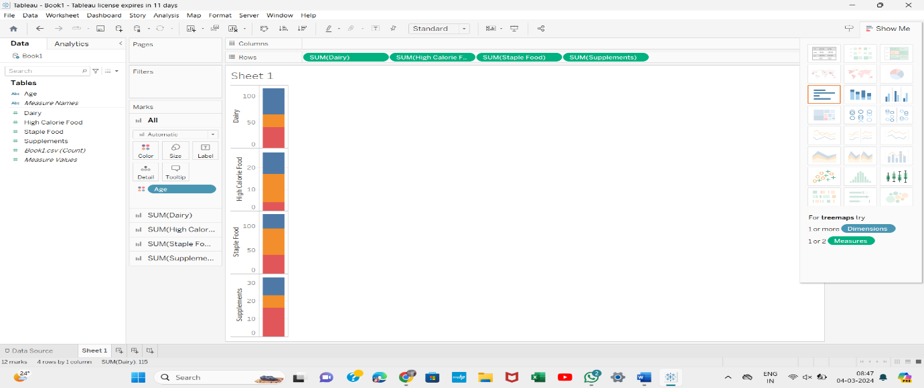

**Mosaic Plot**

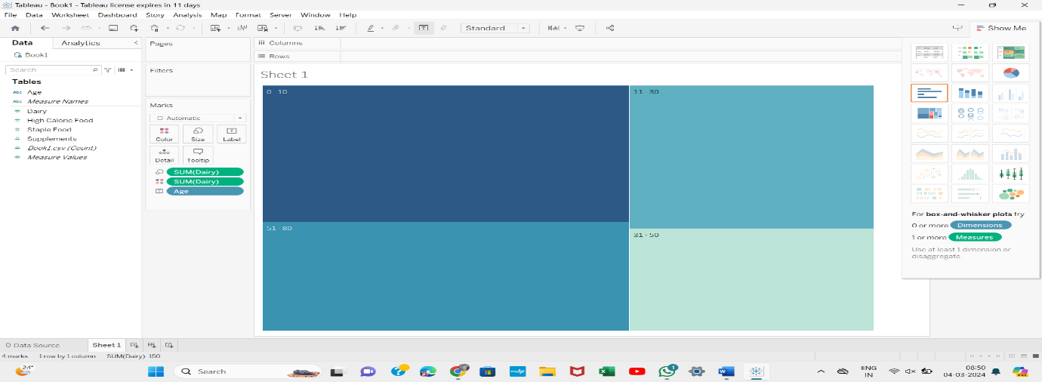

**Scatter Plot**

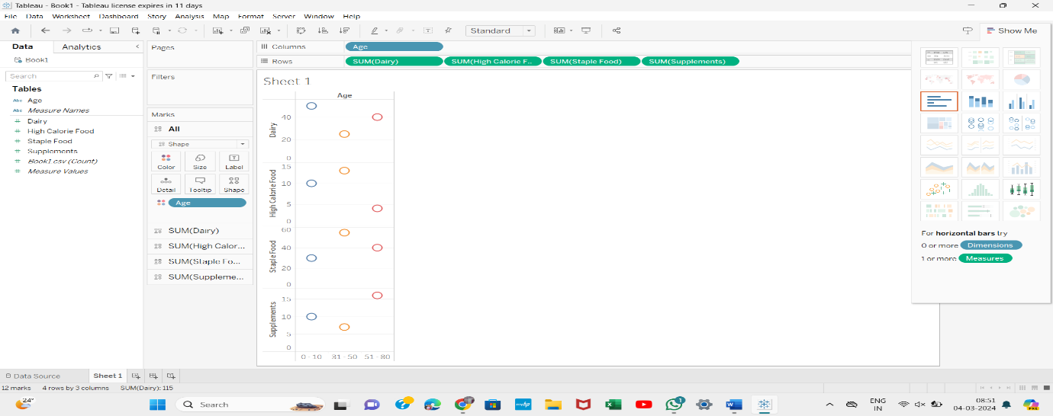

**Line Chart**

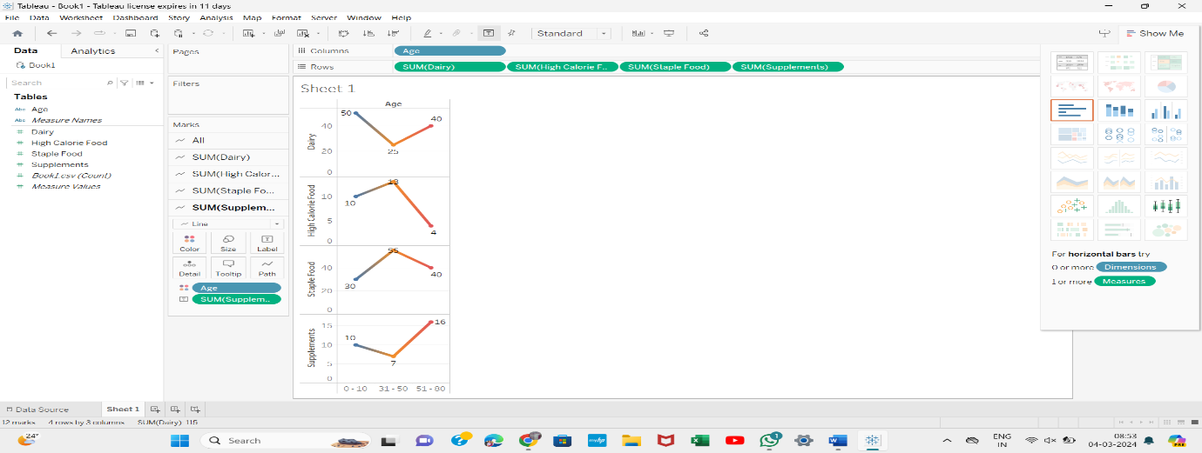

**Case Study 2:** Product Inventory Management - Stacked Bar Chart, Line Plot, Scatter Plot and Pie Plot, Histogram

**Histogram**

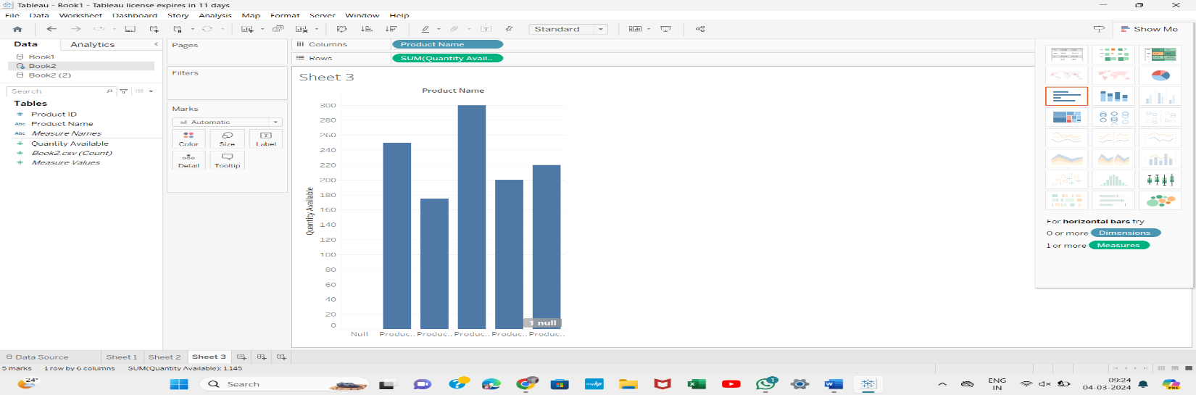

**Stacked Bar**

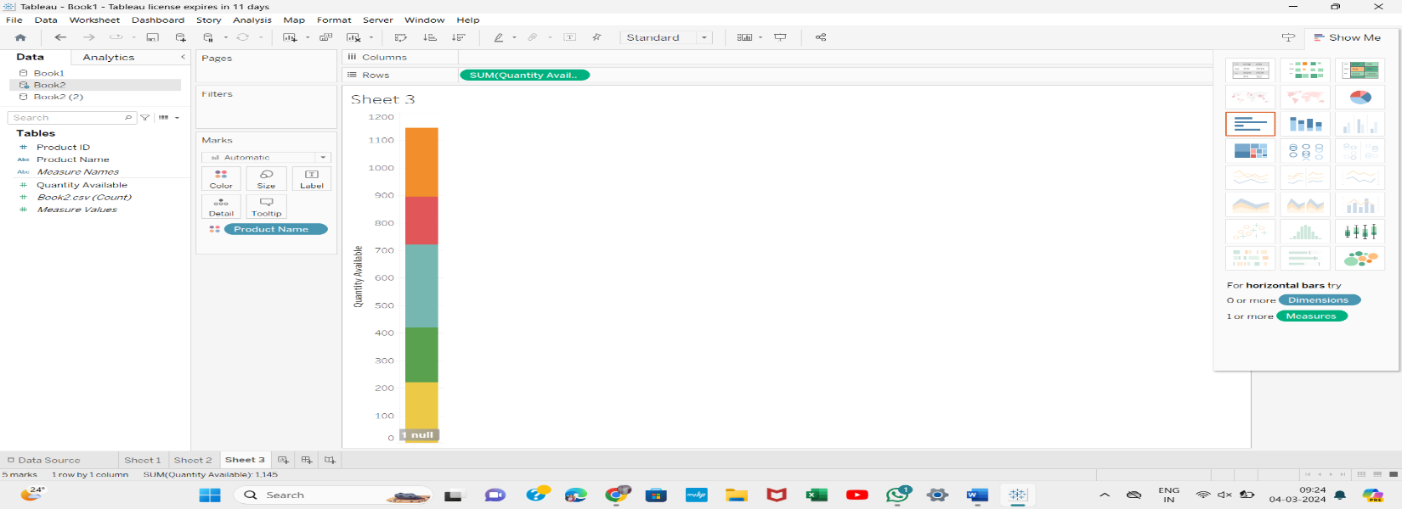

**Pie**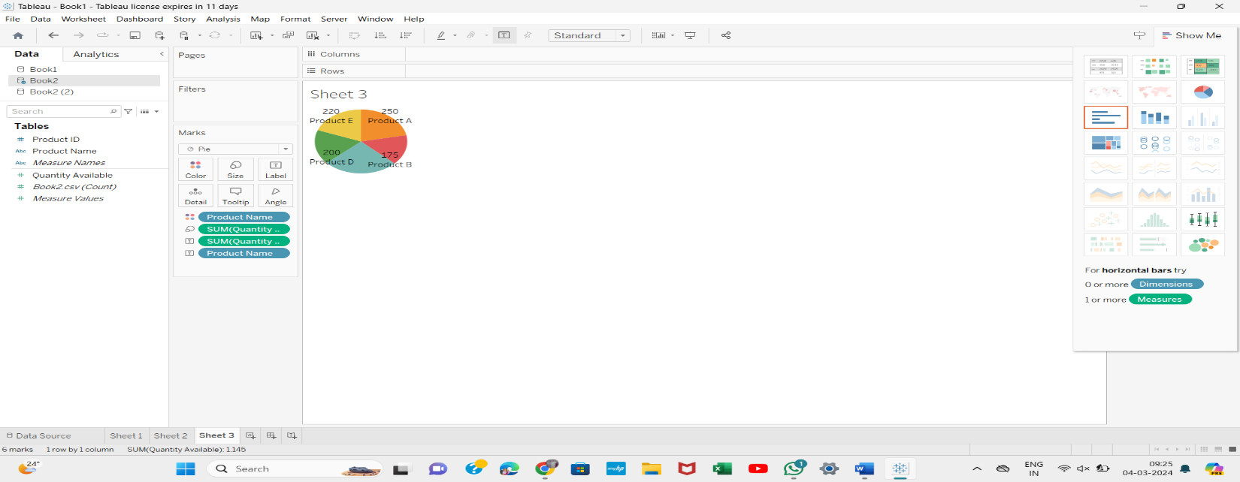

**Line Chart**

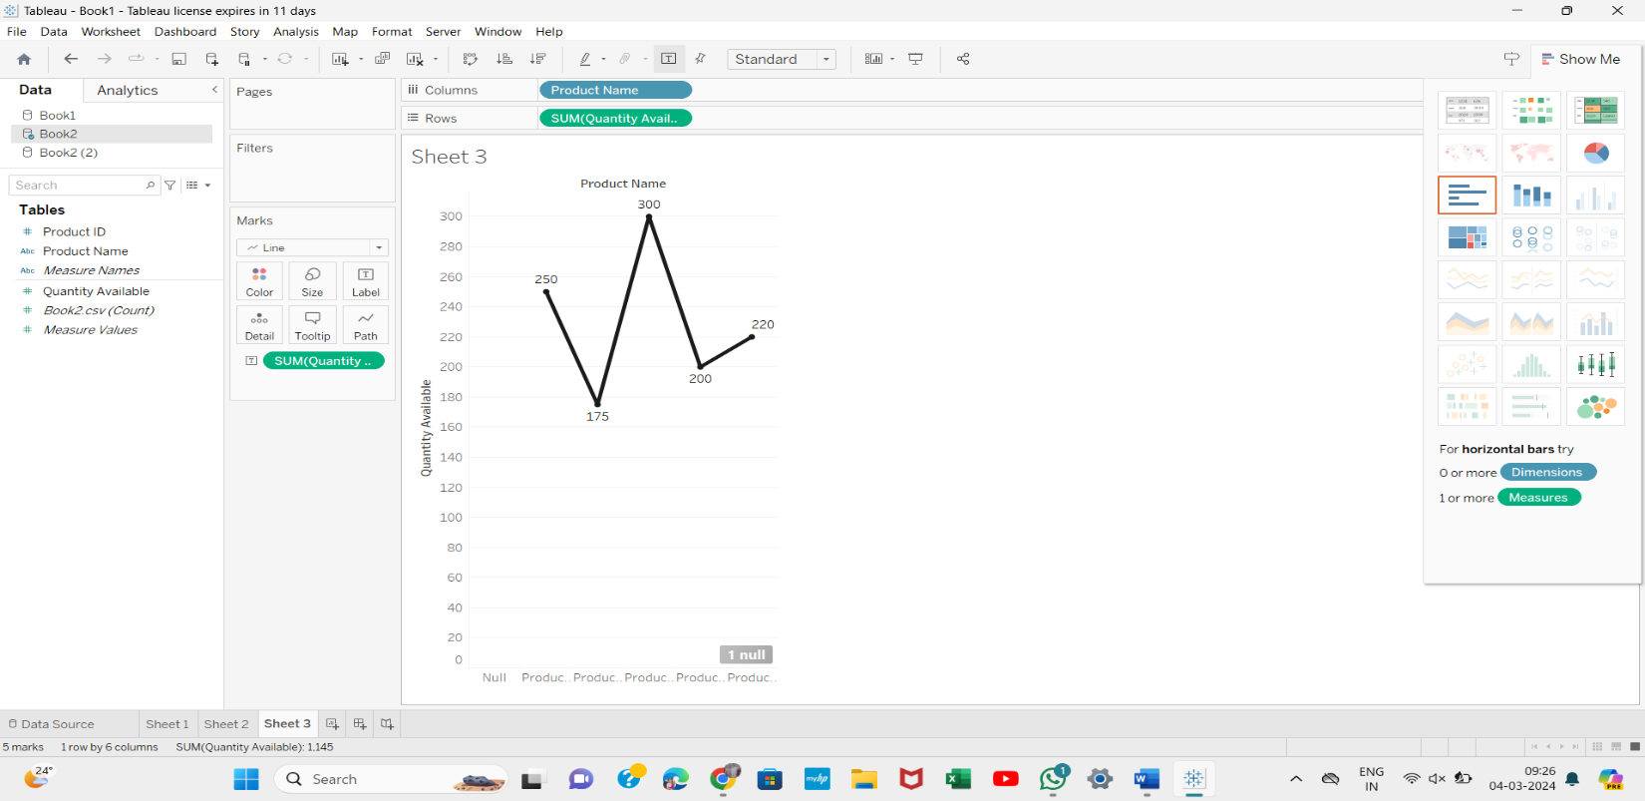

**Scatter Plot**

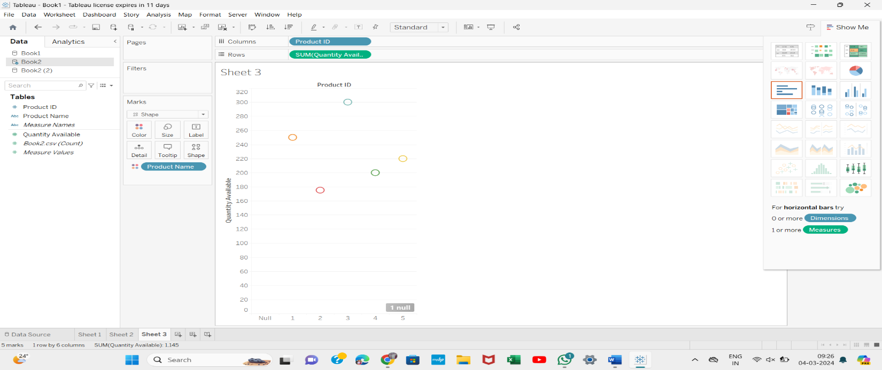

**Case Study 3:** Website Analytics - Stacked Bar Chart, Line Plot, Scatter Plot and Pie Plot, Histogram.

**Scatter Plot**

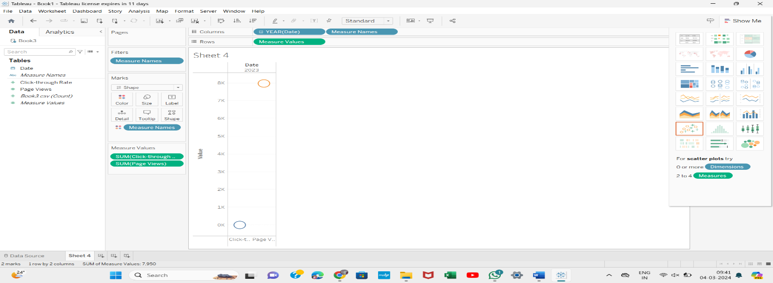

**Pie**

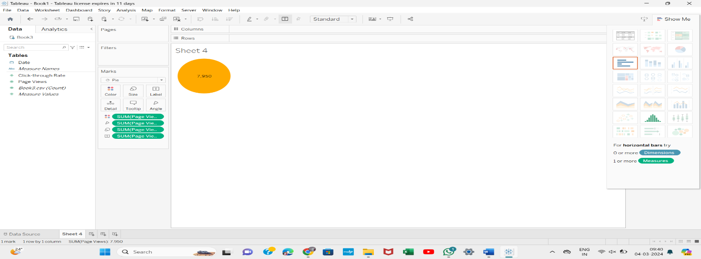

**Bar Plot & Histogram**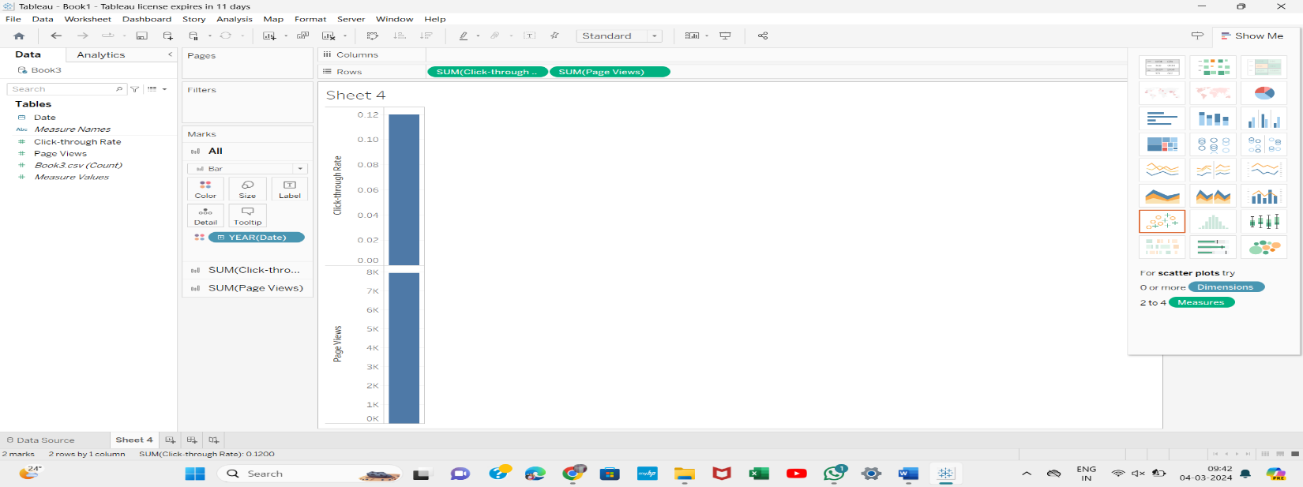

**Case Study 4:** Time Series Analysis – Scatter plot, Line Graph

**Scatter Plot**

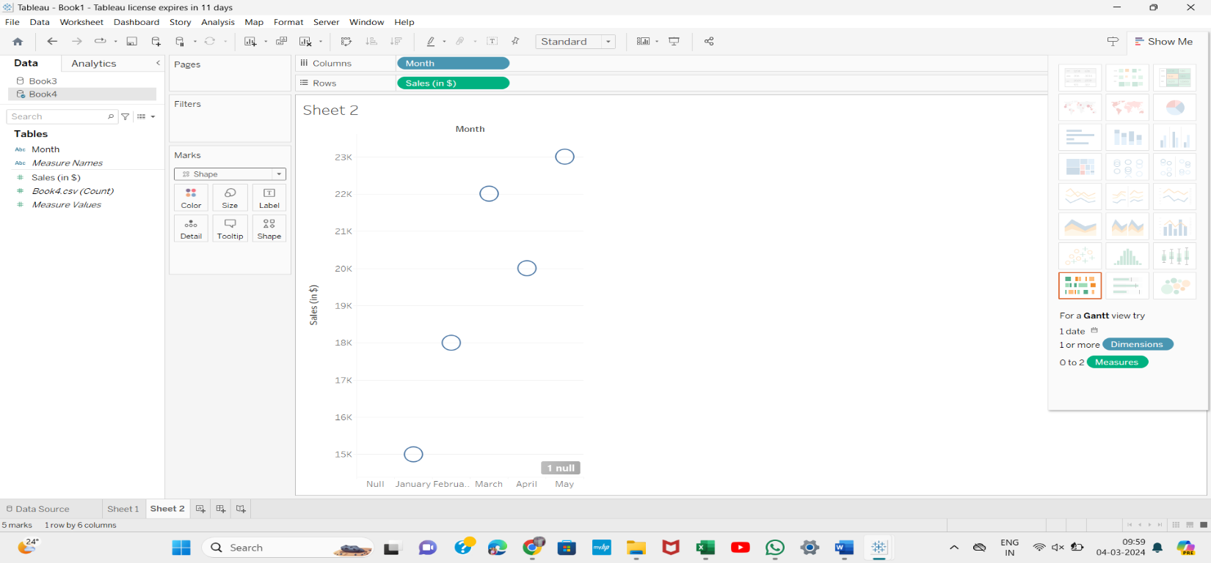

**Line Plot**

